TITLE
The effects of nondimentionalization in Physics-Informed Neural Networks applied to the Kinetics of Biological Reactions: A case study with Lactobacillus casei

AUTHOR LIST
Renan Mendes Frotaª, Ivanildo José da Silva Junior^{a,*}, Amaro Gomes Barreto Junior^{b}.

ª Universidade Federal do Ceará, Departamento de Engenharia Química, Campus do Pici, Bloco 709, 60455-760 Fortaleza, CE, Brazil

^{b} Chemical and Biochemical Engineering Processes (EPQB), School of Chemistry—EQ/UFRJ, Universidade Federal do Rio de Janeiro (UFRJ), Cidade Universitária, Ilha do Fundão, Rio de Janeiro 21949-900, Brazil

*Corresponding author.
Email address: ivanildo@ufc.br
Full postal address: Universidade Federal do Ceará, Departamento de Engenharia Química, Campus do Pici, Bloco 709, 60455-760 Fortaleza, CE, Brazil
- Figures

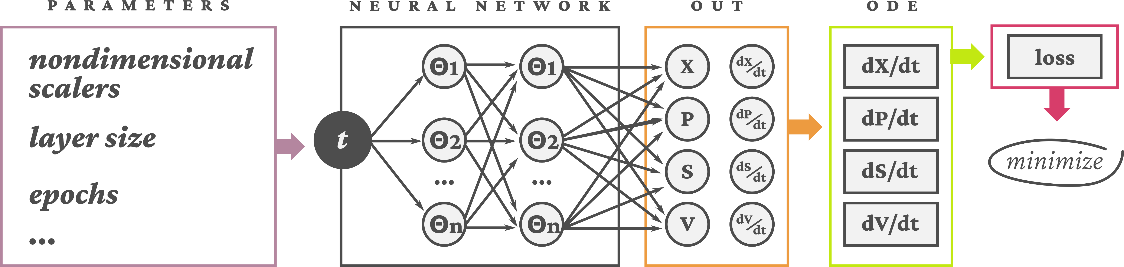Figure 1: Schematic of the PINN model
Figure 2: Nondimensional test, layer test and comparison between experimental data and PINN results
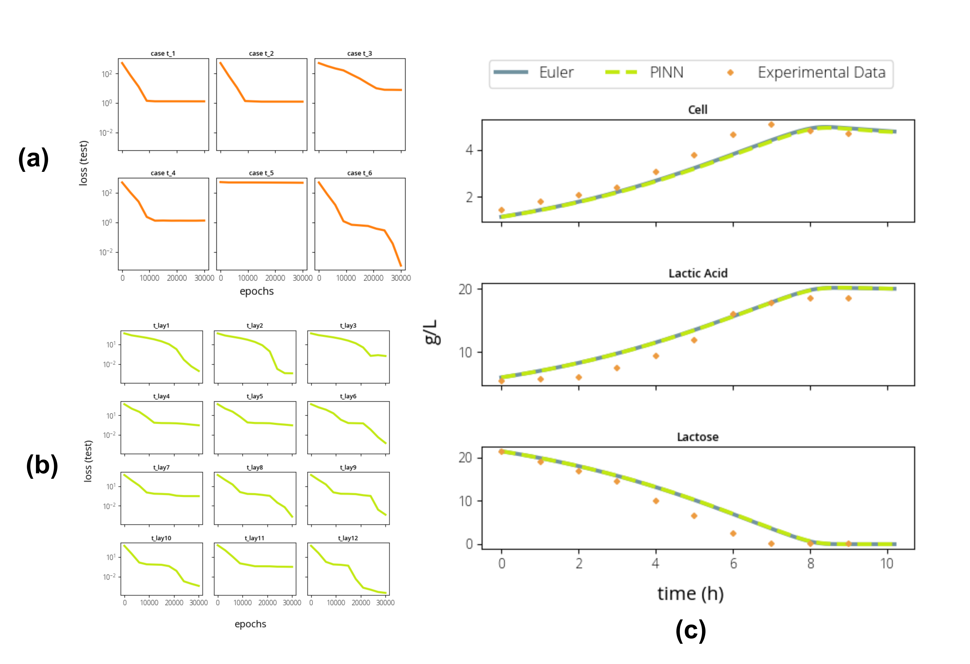

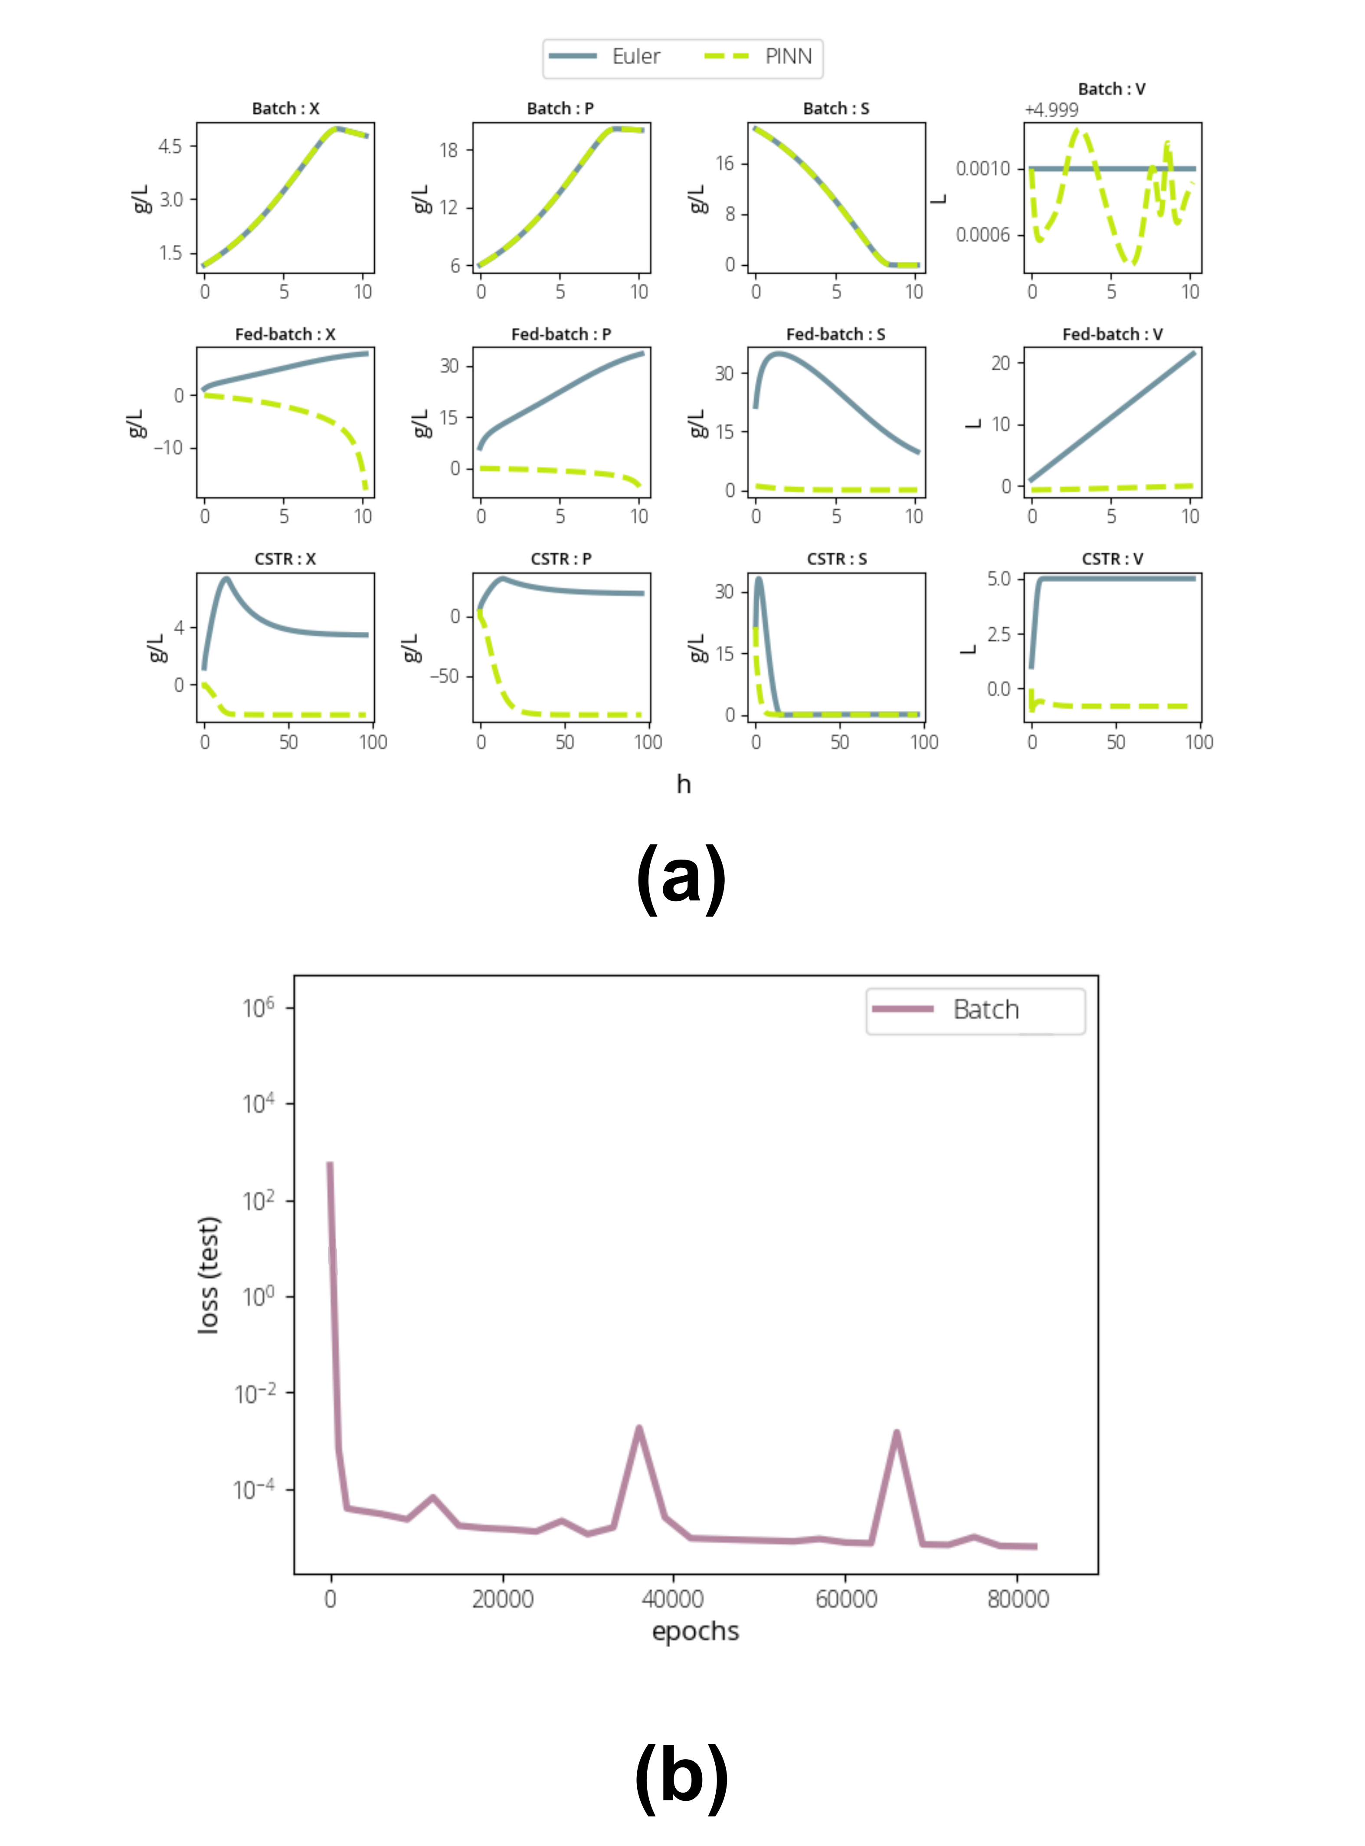Figure 3: PINN results comparison for Bacth, Fed-batch and CSTR reactors
- Declaration of interest
Declarations of interest: none
- Highlights
- Volume and biomass concentration are the more relevant variables for loss minimization
- The batch reactor was successfully simulated using PINN
- PINNs were not capable of appropriately simulate reactors with volume variation
- Strategies for simulating reactors with volume in transient state are suggested

